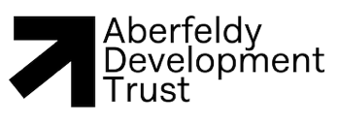
Aberfeldy Affordable Housing Development at Corran Rèil
Public Consultation - Feedback form
Thank you for coming to today's event. We hope that you found it useful, and it has given you more of an understanding about our proposals to develop up to eight affordable houses in Aberfeldy. We would appreciate your feedback on today’s event, your experience, and the information presented. Please answer the questions below and put your questionnaire in the feedback box on the front desk.
1) Are you aware that there is an affordable housing shortage for local people in Aberfeldy? (Please tick one)
☐ Yes, I am aware
☐ No, I was not aware

2) Do you agree or disagree that the proposed development at Corran Rèil will help to address the housing shortage in the area and is positive development? (Please tick one)
☐ Agree
☐ No opinion
☐ Disagree
Why:

3) Do you have any feedback on the information presented today?
☐ Yes, please provide details in the space below
☐ No opinion
☐ No
Comments:

4) Name, address and email address for follow-up questions (we will not publish this information)

